input.doc
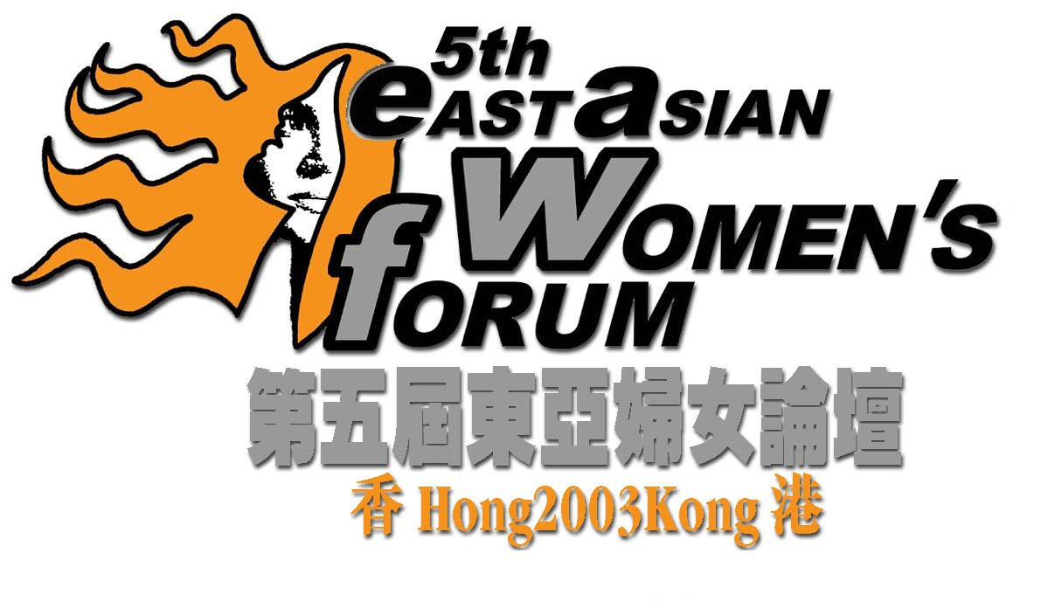
“Embracing New Challenges : Women in Action”
19th – 22nd December 2003
Venue: Hong Kong Baptist University

Forum Registration Form

Please TYPE or PRINT in BLOCK LETTERS and return this form to the Forum Secretariat:
Room 09, 17/F., Prosper Commercial Building, 9 Yin Chong Street, Kln, Hong Kong
Tel: (852) 2374 1268 Fax: (852) 2396 6465 E-mail: info_5eawf@genesismarketing.com.hk Website: www.eawf.org
Personal Information
Please type or print in block letters and “√” where appropriate.
Surname: Mr / Ms ______________________________ |  |  |  | Given Name: __________________________________________________
Position: ____________________________________________________________________________________________________
Organization: ________________________________________________________________________________________________
Badge Name, Title and Organization: (Name exactly as you wish it to be on your name badge; limit to 50 characters.)
___________________________________________________________________________________________________________
Mailing Address: | _____________________________________________________________________________________________
___________________________________________________________________________ |  |  |  |  |  | Postal Code: ___________________
Tel: _________________________ |  | Fax: ___________________________ |  |  | E-mail: ________________________________________
Emergency Phone Number: ______________________ |  |  | Contact Name: _________________________________________________

Areas of concern
Please check the boxes to indicate the programs you would like to join. (Enclosed please find the Forum’s 4-day schedule)
19/12 (Fri) | 20/12 (Sat) |  | 21/12 (Sun) |  |  | 22/12 (Mon)
  18:00 – 21:00
  【Welcome Reception】
  08:30 – 10:00
  Plenary Session I
  【Globalization/ Feminization of Poverty】
  10:30 – 12:30
   | 【Economic Participation】 | Workshop
   | 【Education】 | Workshop
   | 【Sexuality】 | Workshop
  Special Caucus
  【Older Women's Forum】
  13:45 – 15:00
  Plenary Session II
  【Gender Mainstreaming/ Central Mechanism】
  15:30 – 17:30
   | 【Migration of Labour】 | Workshop
   | 【Health】 | Workshop
   | 【Peace】 | Workshop
   | 【ICT】 | Workshop
  Special Caucus
  【Disable Women’s Forum】
  17:30 – 19:30
   | 【Activities Session】
  20:30 – 23:00
  Special Caucus
  【Young Women’s Forum】
  Special Caucus
  【Disable Women’s Forum】
  08:30 – 10:00
  Plenary Session III
  【Traditional Value/ Family Dynamic】
  10:30 – 12:30
   | 【Sex Work】 | Workshop
   | 【Religion and Spirituality】 | Workshop
   | 【Sexual Violence】 | Workshop
  Special Caucus
  【Young Women's Forum】
  14:00 – 16:00
   | 【Environment】 | Workshop
   | 【Urbanization】 | Workshop
   | 【Domestic Violence】 | Workshop
  Special Caucus
  【Young Women’s Forum】
  16:30 – 22:30
  【Local Tour A】16:30 – 20:30
  (additional charges, see next pg)
  【Local Tour B】16:30 – 20:30
  (additional charges, see next pg)
  Special Caucus
  【Young Women’s Forum】
  19:30 – 21:00
   | 【Cultural Night】20:30 – 22:30
  08:30 – 11:30
  【Closing Section】
  14:30 – 18:30
  【Local Tour C】
  (additional charges,
  see next pg)
Other Services Requested
Travel with wheelchair? |  | - No |  | - Yes
Rehabilitation bus service required? |  | - No |  | - Yes
Child care service: |  | Number of Child ______________________ |  |  | Age ________________________
Simultaneous interpretation service required: |  | - Cantonese |  | - Putonghua | - English
Other request, please specify: _______________________________________________________________________________

Local tour Arrangement
Tour & NGO Visit | Tour A  Women & Housing in HK  Sight visit to public & private housing estate | Tour B  Women & Food in HK  “Food & Culture” | Tour C  Women & Consumption in HK  Experience the glamour of shopping paradise
Date | 21/12/2003 (Sunday) 4:30-8:30 p.m. |  | 22/12/2003 (Monday) 2:30-6:30 p.m.
Tour Fee | US$10 / HK$80  (Afternoon tea set inclusive) | US$8 / HK$60  (Afternoon tea set inclusive) | US$8 / HK$60
Description | Visiting different types of housing in Hong Kong to give you a touch of lives of Hong Kong women of different socio-economic backgrounds.  Scenic spot:  Tai Hang Tung Public Housing Estate, Kowloon Tong residential area, afternoon tea at Yau Yat Chuen.  NGO visit to Hong Kong Young Women’s Christian Association | Preparing meals for family members is a major task of women. Sightseeing several scenic spots give you some clues of the changing roles of Hong Kong women.  Scenic spot:  “Da Pai Dang”, Sham Shui Po Wet Market, Supermarket & Foodcourt at Olympic City  NGO visit to Hong Kong Federation of Women’s Centre | Visiting different types of shopping areas helps you to understand consumption styles of marked contrast. You may do some shopping as well.  Scenic spot:  Tsim Sha Tsui, “Ladies’ Market  NGO visit to Hong Kong Women Worker’s Association

Accommodation Reservation Form
For the convenience of participants of 5EAWF, accommodation inside the campus of Hong Kong Baptist University is provided. The Accommodation Package offers four days and three nights’ accommodation of a twin-bed room (double occupancy). Breakfast, lunch and dinner during the forum period (8 meals in total) are included.
Venue |  | Room Type | Room Rate for  4 Days and 3 Nights  Between Dec 19 and 22, 2003 | Arrival Flight  & Time | Departure Flight & Time
Ng Tor Tai  International House (NTT) |  | Twin-bed Room,  (Individual toilet/shower facility) | †US$200 or HK$1,600 Net per person
† Occupancy: | I will share a room with ________________________________________________________ (Name of person).

Notes:
- NTT provide no disable facility. For disabled participants, please contact our Forum Secretariat for special arrangement.
- Check-in time is 1 pm; Check-out time is 12 noon.
- Owing to the limited number of accommodations available, we encourage early registration.

Payment Declaration
I would like to settle: | - Registration Fee * US$ 50.00 / * HK$ 400.00; (Registration fee covers forum materials, coffee breaks, pick-up service from / to the airport & Welcome Reception Cocktail.)  - Local Tour Fee – Tour A * US$ 10.00 / * HK$ 80.00;  - Local Tour Fee – Tour B * US$ 8.00 / * HK$ 60.00;  - Local Tour Fee – Tour C * US$ 8.00 / * HK$ 60.00;  - Accommodation Fee * US$ 200.00 / * HK$ 1,600.00;
in a total of (*Please delete if appropriate.) * US$_________ / * HK$ _________ by:
- Visa | - MasterCard
Card Number: ___________________________________________________ Expiry Date (MM/YY): ______________________

Print Cardholder’s Name: ___________________________________________________________________________________

Cardholder’s Signature: ______________________________(DO NOT PRINT) Date: ___________________________________
I hereby authorize Forum Secretariat to debit my account for the above-mentioned amount.

- Telegraphic Transfer (T.T.) (# ___________________ ) payable to "5EAWF":
Account Number: 257-4-706434
Banker: Hang Seng Bank Limited
Address: 83 Des Voeux Road Central, Hong Kong
Swift Code: HASEHKHH
Please send the receipt together with this registration form to the secretariat.

invoice
Please provide the requested information for the person and organization to be invoiced.
Surname: Mr / Ms _______________________________ |  |  | Given Name: __________________________________________________
Organization: __________________________________________________________________ |  |  |  |  | Position: ______________________
Mailing Address: | _____________________________________________________________________________________________
___________________________________________________________ |  |  |  | Postal Code: ___________________________________
Tel: _________________________ |  | Fax: _________________________ |  | E-mail: ________________________________________

IMPORTANT NOTES:
- ONE registration form is for ONE person only. Please use separate form if more than one person register for the Forum. Photocopying of this form is acceptable.
- Registration forms received without registration fees paid will not be processed. Please do not send cash.
- The Forum program is subject to change without prior notice. In the unlikely event of cancellation of the Forum, the only liability of the organizing committee is to refund all the fees paid.
- Refunds for cancellations of registration will be made subject to the following deadline and charges after the Forum:
On or before Sep 30 2003 Full Refund less processing fee charged by the bank.
Between Oct 1 and Nov 30 2003 Will be given a 50% refund.
After Nov 30 2003 No Refund.
All cancellations must be made in writing by mail, fax or email to the Forum Secretariat. Refunds will be made within one month after the Forum.
- The information provided in this form will only be used for the purposes of processing your registration, communicating with you on matters related to the Forum. Participants and organization name will be shown on the Forum Handbook. You can decide not to disclose your information in the forum handbook, or you can have access and correction with respect to your personal data held by us. If you wish to exercise these rights, please contact the Forum Secretariat.

________________________________________________ | _________________________________________________
Signature  I hereby agree to be bound by the rules and regulations of the Forum | Date

Post - Forum Accommodation Reservation Form
YWCA has offered special packages to our overseas delegates for post-forum staying in Hong Kong (from Dec22 to Dec31 2003). Please fill in the form below if such is required, we will pass the booking to YWCA.
Venue | Room Type | Room Rate Per Night  (Inclusive of set breakfast) | Date In | Date Out | Departure Flight & Time
YWCA Garden View International House | Standard Room (Twin) | US$64 or HK$495 Net
YWCA Anne Black Guest House | Standard Room (Twin) | US$47 or HK$363 Net
I hereby authorize Forum Secretariat to pass my personal information to YWCA.

NOTES:
- The 5th East Asian Women’s Forum WILL NOT be in charge for the post-forum accommodation, please make your payment to YWCA separately.
- The special room rate is only valid during the Forum period for delegates attending the 5th East Asian Women’s Forum and will be subject to the availability of rooms.
- For further information, please visit Hong Kong YWCA website http://www.ywca.org.hk

