input.doc
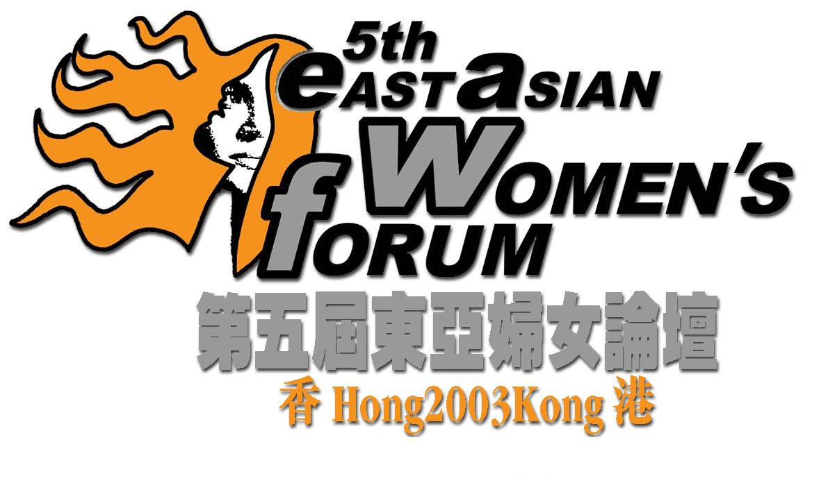
“Embracing New Challenges : Women in Action”
19th – 22nd December 2003
Venue: Hong Kong Baptist University

Forum Registration Form

Please TYPE or PRINT in BLOCK LETTERS and return this form to the Forum Secretariat:
Room 09, 17/F., Prosper Commercial Building, 9 Yin Chong Street, Kln, Hong Kong
Tel: (852) 2374 1268 Fax: (852) 2396 6465 E-mail: info_5eawf@genesismarketing.com.hk Website: www.eawf.org

Personal Information
Please type or print in block letters and “√” where appropriate
Surname: Mr / Ms ______________________________ |  |  |  | Given Name: __________________________________________________
Position: ____________________________________________________________________________________________________
Organization: ________________________________________________________________________________________________
Badge Name, Title and Organization: (Name exactly as you wish it to be on your name badge; limit to 50 characters.)
___________________________________________________________________________________________________________
Mailing Address: | _____________________________________________________________________________________________
Tel: _________________________ |  | Fax: ___________________________ |  |  | E-mail: ________________________________________
Emergency Phone Number: ______________________ |  |  | Contact Name: _________________________________________________

Areas of concern
Please check the boxes to indicate the programs you would like to join.
19/12 (Fri) | 20/12 (Sat) |  | 21/12 (Sun) |  |  | 22/12 (Mon)
  18:00 – 21:00
  【Welcome Reception】
  ($120 per person)
  08:30 – 10:00
  Plenary Session I
  【Globalization/ Feminization of Poverty】
  10:30 – 12:30
   | 【Economic Participation】 | Workshop
   | 【Education】 | Workshop
   | 【Sexuality】 | Workshop
  Special Caucus
  【Older Women's Forum】
  13:45 – 15:00
  Plenary Session II
  【Gender Mainstreaming/ Central Mechanism】
  15:30 – 17:30
   | 【Migration of Labour】 | Workshop
   | 【Health】 | Workshop
   | 【Peace】 | Workshop
   | 【ICT】 | Workshop
  Special Caucus
  【Disable Women’s Forum】
  17:30 – 19:30
   | 【Activities session】
  20:30 – 23:00
  Special Caucus
  【Young Women’s Forum】
  Special Caucus
  【Disable Women’s Forum】
  08:30 – 10:00
  Plenary Session III
  【Traditional Value/ Family Dynamic】
  10:30 – 12:30
   | 【Sex Work】 | Workshop
   | 【Religion and Spirituality】 | Workshop
   | 【Sexual Violence】 | Workshop
  Special Caucus
  【Young Women's Forum】
  14:00 – 16:00
   | 【Environment】 | Workshop
   | 【Urbanization】 | Workshop
   | 【Domestic Violence】 | Workshop
  Special Caucus
  【Young Women’s Forum】
  16:30 – 22:30
  【Local Tour A】
  16:30 – 20:30
  ($80 per person, see next page)
  【Local Tour B】
  16:30 – 20:30
  ($60 per person, see next page)
  Special Caucus
  【Young Women’s Forum】
  19:30 – 21:00
  【Cultural Night】
  20:30 – 22:30
  08:30 – 11:30
  【Closing Section】
  14:30 – 18:30
  【Local Tour C】
  ($60 per person,
  see next page)
Other Services Requested
Travel with wheelchair? |  | - No |  | - Yes
Rehabilitation bus service required? |  | - No |  | - Yes
Simultaneous interpretation service required: |  | - Cantonese |  | - Putonghua | - English
Other request, please specify: ___________________________________________________________________________________

Local tour Arrangement
Tour & NGO Visit | Tour A  Women & Housing in HK  Sight visit to public & private housing estate | Tour B  Women & Food in HK  “Food & Culture” | Tour C  Women & Consumption in HK  Experience the glamour of shopping paradise
Date | 4:30-8:30 p.m.  21/12/2003 (Sunday) |  | 2:30-6:30 p.m.  22/12/2003 (Monday)
Tour Fee | HK$80  (Afternoon tea set inclusive) | HK$60  (Afternoon tea set inclusive) | HK$60
Description | Visiting different types of housing in Hong Kong to give you a touch of lives of Hong Kong women of different socio-economic backgrounds.  Scenic spot: Tai Hang Tung Public Housing Estate, Kowloon Tong residential area, afternoon tea at Yau Yat Chuen.  NGO visit to Hong Kong Young Women’s Christian Association | Preparing meals for family members is a major task of women. Sightseeing several scenic spots give you some clues of the changing roles of Hong Kong women.  Scenic spot: “Da Pai Dang”, Sham Shui Po Wet Market, Supermarket & Foodcourt at Olympic City  NGO visit to Hong Kong Federation of Women’s Centre | Visiting different types of shopping areas helps you to understand consumption styles of marked contrast. You may do some shopping as well.  Scenic spot:  Tsim Sha Tsui, “Ladies’ Market  NGO visit to Hong Kong Women Worker’s Association

Payment Declaration
I would like to settle: |  | - Registration Fee HK$ 250.00; (Registration fee covers forum materials and coffee breaks.)  - Welcome Reception Fee HK$ 120.00;  - Local Tour Fee – Tour A HK$ 80.00;  - Local Tour Fee – Tour B HK$ 60.00;  - Local Tour Fee – Tour C HK$ 60.00;
in a total of HK$ _____________ by:
- Visa | - MasterCard
Card Number: __________________________________________________________ Expiry Date (MM/YY): _____________

Print Cardholder’s Name: ___________________________________________________________________________________

Cardholder’s Signature (DO NOT PRINT): ______________________________________ Date: __________________________
I hereby authorize Forum Secretariat to debit my account for the above-mentioned amount.
- Cheque (# __________________ ).
Please prepare a cross cheque payable to "5EAWF" and send to the Forum Secretariat together with the registration form.

- Directly Transfer to Hang Seng Bank Limited (Account Number: 257-148585-001).
Please send back the original pay-in-slip together with this registration form.

invoice (Please provide the requested information for the person and organization to be invoiced.)
Surname: Mr / Ms _______________________________ |  |  | Given Name: __________________________________________________
Organization: __________________________________________________________________ |  |  |  |  | Position: ______________________
Mailing Address: | _____________________________________________________________________________________________
Tel: _________________________ |  | Fax: _________________________ |  | E-mail: ________________________________________

IMPORTANT NOTES:
- ONE registration form is for ONE person only. Please use separate form if more than one person register for the Forum. Photocopying of this form is acceptable.
- Registration forms received without registration fees paid will not be processed. Please do not send cash.
- The Forum program is subject to change without prior notice. In the unlikely event of cancellation of the Forum, the only liability of the organizing committee is to refund all the fees paid.
- Refunds for cancellations of registration will be made subject to the following deadline and charges after the Forum:
On or before Sep 30 2003 Full Refund.
Between Oct 1 and Nov 30 2003 Will be given a 50% refund.
After Nov 30 2003 No Refund.
All cancellations must be made in writing by mail, fax or email to the Forum Secretariat. Refunds will be made within one month after the Forum.
- The information provided in this form will only be used for the purposes of processing your registration, communicating with you on matters related to the Forum. Participants and organization name will be shown on the Forum Handbook. You can decide not to disclose your information in the forum handbook, or you can have access and correction with respect to your personal data held by us. If you wish to exercise these rights, please contact the Forum Secretariat.
________________________________________________ | _________________________________________________
Signature  I hereby agree to be bound by the rules and regulations of the Forum | Date

